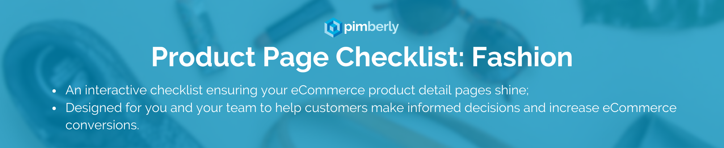

Product Data | Cross if applicable
Product images
💡Along with pricing (see ‘Shipping & Pricing’), images should be #1 priority. Include various high-quality images from multiple angles. Aim for a minimum of 3-5. Use lifestyle images and additional angles.

Product Title
💡Use a concise but descriptive title to represent the product.
Product Description
💡Include key features, materials, manufacturing techniques. Be consistent with brand tone of voice.
Size & Fit
💡If your product images include a model, include their sizing information
Colour & Style Options
💡 If your product has variants, make sure you list them.
Care Instructions
💡Include fabric & material information. Can the item be dry cleaned? Does it need to be ironed inside out?
Availability & Stock
💡If an item is out of stock, update interested customers when it’s available.
Sustainability Credentials
💡Include certification (Fairtrade, etc) and include if your product features recycled materials or the packaging is biodegradable.

Continued on next page…

Page Layout & Features | Cross if applicable
Simple Navigation & Breadcrumbs
💡Generally, we recommend avoiding horizontal tabs. Instead, choose vertically collapsed sections to display core product content.
Trust Badges and Security
💡Include secure payment certifications to build trust
Product Recommendations
💡Cross-sell products to increase average order value. If your images feature a model, recommend other items from their outfit.
Clear Call-to-action Buttons
💡No one wants to click ‘Buy Now’ and be taken to a page where they have to insert their email and password.
Social Sharing Buttons
💡Allow users to quickly share your products on Instagram, Facebook, or Twitter
‘Buy Now’ Option
💡This will encourage impulse purchases and eliminates friction in the customer journey.

Shipping & Pricing | Cross if applicable
Shipping & Delivery Information
💡Don’t give the customer any nasty surprises when they’re about to purchase the item. Be transparent about delivery costs and shipping times.
Pricing & Discounts
💡Provide clear and transparent pricing consistent with formatting across your website.
Returns Policy
💡Clearly outline your returns policy, make it easily identifiable, and include links to your returns portal

Social Proof | Cross if applicable
Customer Reviews & Ratings
💡Reviews build trust and increase the credibility of your products
Influencer Endorsements
💡If your product has been featured by influencers in the fashion sector, display their testimonials supporting your product

Pimberly’s fashion & apparel customers to check out:

JD Sports
FootAsylum
Monsoon
Harvey Nichols
Boden
Monsoon
Go Outdoors
Regatta
Lakeland Leather
Cotton Traders

Further reading:

Customer Case Study: Gill Marine

Whitepaper: Creating the Perfect Product Detail Page

Whitepaper: Fashion & Apparel eCommerce KPIs and How PIM Helps You Smash Them

Whitepaper: Sustainability in Fashion and Apparel

Whitepaper: Why Fashion & Apparel Needs PIM

Blog: Fashion Omnichannel Guide: Drive Sales Online & In-Store

Blog: Why Visual Merchandising Is Integral to Building Trust

Blog: How to Improve Online Sales with Product Information

